**Back pain with sciatica**

**Initial Assessment**

|  |  |  |
| --- | --- | --- |
| **Presenting Symptom/Chief Complaint** | | |
| Acute episode of low back pain with radiation to the legs due to cold and wind invasion**.** Pain is based of Qi kidney deficiency with Qi and blood stagnation at the area. | | |
| **Main Signs and Symptoms** | | |
| Patient is complaining of repeated acute episode of back pain with radiation to the legs. **Strain** sprain of the muscle and weaken Kidney Qi. | | |
| **Other Signs and Symptoms** | | |
| Otherwise patient is healthy. | | |
| **TCM Diagnosis and Treatment (identified TCM disease, TCM differentiation of syndromes)** | | |
| Acute painful obstruction syndrome of the back area with pain. Dampness invasion and cold and wind predisposition. Kidney Qi deficiency (weakness) and Qi stagnation. | | |
| **Treatment Principles and Strategies** | | |
| Expel wind remove the cold and dampness; Nourish Kidney Qi. Remove the muscle spasm and circulatory limitation. | | |
| **Treatment Plan (Modalities; acupuncture, herbal, dietary, manual therapies), frequency and duration** | | |
| Acupuncture 2-3 times a week with starting of local point’s primary to distal till the symptoms resolved.  Acupuncture: SI3 (L) 1st + UB62 (r) 2nd – opening the **Governing Vessel.** | | |
| **Any other Advice Given to Patients** | | |
| UB 60; Ki 4 – tonification of Kidney Qi  SP 6, Du 20; - effect the Governing Vessels.  H7 (R) Calming mind and relaxing the spasm muscle.  Combination of source and back. SHUpoints at the area and for the main channels involved.  SP3 – UB 20 (bilaterally) for muscle spasm (SP)  K3 – UB 23 (bilaterally) Bone pain (Ki Channel)  UB11 – GB39 (bilaterally) Cartilage involvement (Liv)  Distal pain for sciatica (full condition due to Dampness - Cold)  UB 40 (for acute period only; UB 60; UB 62 (hip)  K4; with combination UB 58 (thigh) | | |
| **Practitioner:** | **Date:** | **Signature:** |

**Daily Charting____________________________________Patient Name:**

**Date:_**

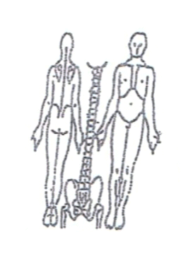**Working Diagnosis:** Acute painful obstruction syndrome at the back area with

main Cold – Wind + Dampness invasion and KiQi depletion and stagnation.

S: Patient is complaining of the episode of acute back pain with strong restriction to movement and radiationof the pain along the side and back to the legs. Syndrome is severe and interferingwith daily living function and sleep.

O:

**Treatment (P)** UB 60; Ki 4 – tonification of Kidney Qi, SP 6, Du 20; - effect the Governing Vessels. H7 (R) Calming mind and relaxing the spasm muscle. Combination of source and back – Shu points at the area and for the main channels involved**.** SP3 – UB 20 (bilaterally) for muscle spasm (SP). K3 – UB 23 (bilaterally) Bone pain (Ki Channel).UB11 – GB39 (bilaterally) Cartilage involvement (Liv).Distal pain for sciatica (full condition due to Dampness - Cold).UB 40 (for acute period only; UB 60; UB 62 (hip).K4; with combination UB 58 (thigh).

(A) Acupuncture 1 hour according to the protocol.

**Date:_**

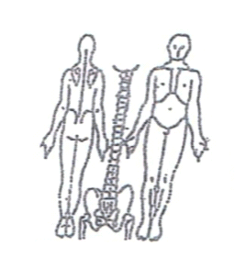**Working Diagnosis:**

S: Pain is still the same 5-6 on the pain scale of 1-10. Severe limitation to movement.

Pain with walking or changing position in the bed.

O:

Treatment (P)

(A) Acupuncture with strong needle stimulation of the distal, points of 10-

15 minutes following by tonification of the local points for 45-50 min

**Date:_**

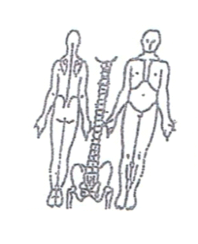**Working Diagnosis:**

S: Pain is still the same. Better movement with back support belt. Better sleep. Daily activity is very limited due to pain.

O:

Treatment (P) Acupuncture with Moxibustion1 hour with needling of Back –

shu points of the main channels involved.

(A)

**Date:_**

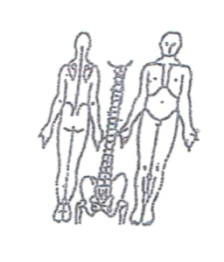**Working Diagnosis:**

S: Pain is still severe with slight decrease of intensity. Radiationof pain to the legs.

ROM. Movement with back support belt.

O:

Treatment (P) Acupuncture with sedation of the distal points following by

tonification of the local points for 1 hour.

(A)

**Daily Charting____________________________________Patient Name:**

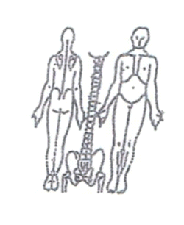**Date:**

**Working Diagnosis:**

S: Pain ↓; 1st time the patient sleep N and wake up energized in the morning. ROM ↑

Still using the back support belt but pain ↓

O:

Treatment (P) Acupuncture with sedation of peripheral needles following by

tonification with warm needles 1 hour.

(A)

**Date: June 06, 2015_____________**

 **Working Diagnosis:**

S: Pain ↓ ;Patient sleeping much better. Level of energy ↑; ROM ↑. Feeling more energized and less pain with movement. Still using back support belt during the day.

O:

Treatment (P) Acupuncture + Moxibustion1 hour according to the treatment plan.

(A)

**Date:_ _______________**

 **Working Diagnosis:**

S: Pain ↓ Rom ↑; daily movement ↑. N sleep. Level of energy ↑ No belt back support used.

O:

Treatment (P) Acupuncture + Moxibustion. Immunostimulating and analgesic

protocol 1 hour used.

(A)

**Date:**

**Working Diagnosis:**

S: Patient is feeling well. No pain at the back area. N Rom. N Sleep. No limitation of daily living. Started remedal exercises.

O:

Treatment (P) Acupuncture + Moxibustion1 hour according to the protocol.

(A)